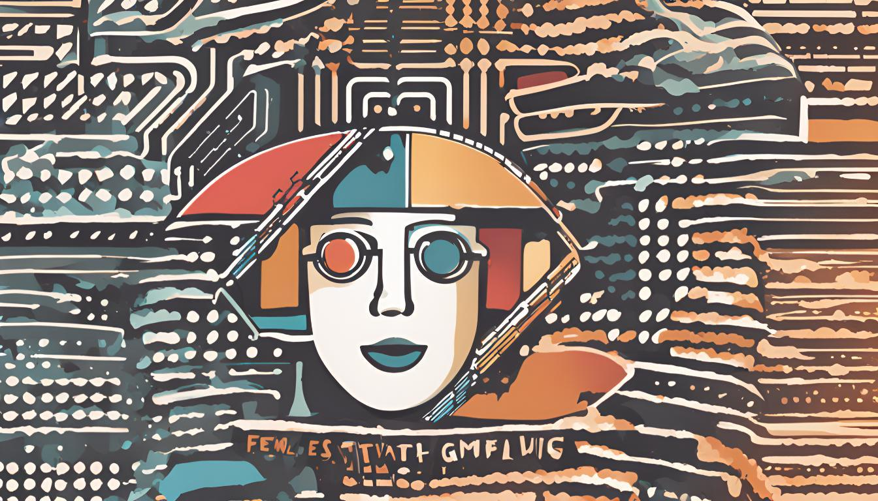

**About Austin AI Film Festival**

The Austin AI Film Festival (AAIFF) is bringing together artists and technologists to celebrate storytelling at Austin, Texas. Our mission is to discover the next generation of narrative storytellers and embrace the role of technology innovation in film production.

AAIFF events span three days between March 7th and 9th, 2025*. On the first day, we discuss film in the age of artificial intelligence from the perspective of the creatives and the entertainment industry. On the second day, we turn to enhancing storytelling from the perspective of artificial intelligence technology. The third day is the main event— an awards show to recognize innovative creatives that leverage artificial intelligence to tell the stories of our times.

**Sponsoring AAIFF**

We are looking to partner with companies that have an interest in building relationships with the members of our community and help steer the future of filmmaking. The firm and technology creatives that participate in the festival represent pioneers of a new age of film. We invite you to partner with us to ensure the future of filmmaking is a beacon of great storytelling.

**Event Schedule**

**Day 1**

***Film in the Age of AI***

*Friday, March 7th 10 AM - Location TBA*

Talks from creators, directors, artists, writers, filmmakers, producers and film executives.

**Day 2**

***Technology Innovation for Content Creation***

*Saturday, March 8th 10 AM - Location TBA*

Talks from professionals working at software companies that are empowering filmmakers.

**Day 3**

***Awards Show***

*Sunday, March 9th 7 PM- Location TBA*

An awards show that celebrates the greatest stories in the age of artificial intelligence

**Sponsorship Opportunities**

**Title Sponsorship**

*Above $20,000*

* + - Your organization will be featured on our website and on all promotional material as top sponsor **and partner**. You will be formally thanked at **all** events and sessions.
    - Your organization will have one spot on the judge’s panel.
    - Your organization will have a **10-minute** period during which you can introduce yourself at the opening of the Awards Show.
    - Your organization representatives are invited to **all** the events and have the ability to manage a permanent presence for the duration of AAIFF.
    - Contact information for all participants will be released to you.
    - A follow-up email will be sent to the AAIFF community to thank you for your role as AAIFF Partner and share any relevant information.

**Award Sponsorship (x2)**

*Above $10,000*

* + - Your organization will be featured on our website and on promotional material as an Awards Show Sponsor.
    - Your organization will have a **5-minute** period during which you can address the community and introduce your award at the Awards Show.
    - Your organization will have the ability to manage a presence for the duration of the AAIFF Awards Show.
    - Contact information for all participants will be released to you.
    - A follow-up email will be sent to the AAIFF community to thank you for your role as AAIFF Award Sponsor and share any relevant information.

**Event Sponsor (x5)**

*Above $5,000*

* + - Your organization will be featured on our website and on promotional material as an Event Sponsor for one of the events in Day 1 or Day 2.
    - Your organization will have a **5-minute** period during which you can address the community at the introduction of your event.
    - Your organization will have the opportunity to hang a banner in the event space.
    - A follow-up email will be sent to the AAIFF community to thank you for your role as Event Sponsor and share any relevant information.

**General Sponsors (x10)**

*Above $2,500*

* + - Your organization will be recognized as a sponsor on our website.
    - A follow-up email will be sent to the AAIFF community to thank you for your role as General Sponsor and share any relevant information.